Equality and Diversity and GDPR E-Learning Modules
Training Manual

Training FAQ’s
- What is GDPR?

GDPR stands for General Data Protection Regulation and is the new European Union Regulation set to replace the Data Protection Directive (DPD) and The UK Data Protection Act 1998.

- Who does GDPR apply to?

Any organisation, which processes and holds the personal data of data subjects residing in the EU, will be obliged to abide by the laws set out by GDPR. This applies to every organisation, regardless of whether or not they themselves reside in one of the 28 EU member states.

- What kind of information does the GDPR apply to?

Much like the Data Protection Act 1998, GDPR applies to personal data. Personal data means any information which relates to identifies an individual.

- What will the penalties be for failing to comply with GDPR?

The GDPR have introduced a tiered approach to fines, meaning that the severity of the breach will determine the fine imposed.

The maximum fine a company can face is 4% of their annual global turnover, or €20 million, whichever is the highest.

Less serious violations, such as having improper records, or failing to notify of any breaches, can be fined a maximum of 2% of their annual global turnover, or €10 million.

- Why do I have to do this training?

It is compulsory for all staff at Liverpool Hope to complete the modules to make sure staff are made aware of the policies and how to collect and handle data in accordance with the law.

- How long does the sessions take to complete?

The modules should take around 30 minutes each.

- Why am I seeing a black screen when opening the module?

When opening the module in Google Chrome, you may come across a black screen when trying to run the module, if you do, please follow the details below:

If you are using Google Chrome, the screen may appear black, this may be because of the google chrome settings. Please open a new webpage and copy the following link into your Chrome search bar: chrome://flags/#autoplay-policy
Scroll down to the highlighted area (should be in yellow)
Then change the policy to No user gesture is required, you should be able to continue with the course.

- Is there a deadline for completion?

The deadline is one month from the date the training module is issued. This is regularly monitored and reminder emails will be sent out to staff until they have completed.

- Do I require Earphones to complete the module?

Yes you will require earphones or speakers to complete this course. Free earphones are available from the Personnel office reception or if you would like to be sent some earphones in the Internal mail, please email HR@hope.ac.uk or contact Ex 3189.

- What happens if I do not pass the E-Learning module?

You can log back in and retake the module assessment by clicking re-launch

- Will staff always have access to this so they can go back and re-read it any issues may arise?

Unfortunately, you are not able to log in once you have passed the course, but you should always refer to Liverpool Hope’s Equality and Diversity Policy or the Data Protection resource page at https://www.hope.ac.uk/aboutus/governance/dataprotection/

You can log in at all times to print your certificate or re-take the course.

- Who do I contact if I have any queries relating to the Training Modules?

Please contact Shauna Anton on antons@hope.ac.uk if you require any assistance or have any queries relating to either module.

- Who do I contact if I have an issue relating to Policy?

For queries relating to the Equality and Diversity training or policy, please refer to the Personnel Office via email on HR@hope.ac.uk. Please contact Laura Gittins on gittinl@hope.ac.uk if you require any assistance or have any queries relating to the GDPR. Laura is the University’s designated Data Protection Officer.

Step One – Get up this link: https://info.hope.ac.uk/myhope3/staff.html
This will take you to the Staff gateway on the Liverpool Hope website. Please click on the blue tab called Staff Development Resource’s and follow the links for the GDPR and Equality and Diversity training modules.
Please note, this is a separate log in to your Hope login, so if you can’t remember your details, you may need to click, reset password. Please find further Instructions below:
Step Two - This page will appear:
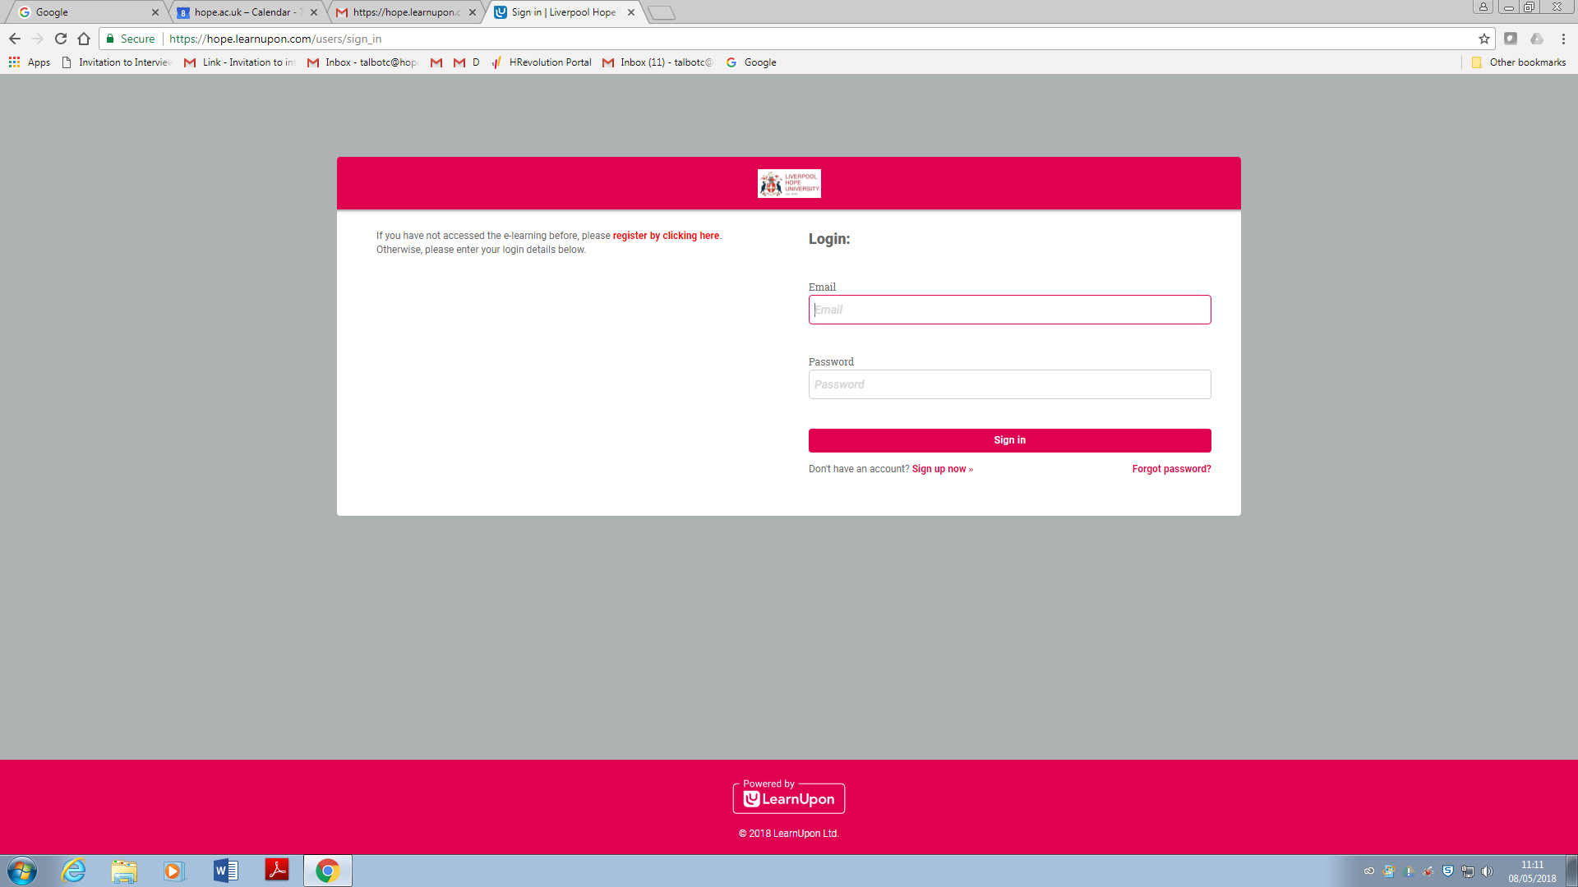

If you have already completed the Equality and Diversity Training module, you will already have a log in. If you cannot remember the password, please click on ‘forget password’ and follow the instructions.
Step Three – Either login or Click ‘Sign up now’
If you get a black screen whilst trying to log into the training package, please go to page 7 of this manual for further instruction.

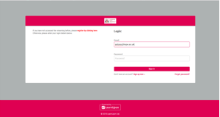

Step Four – If it is your first time logging in, enter your Hope email address and create a password.
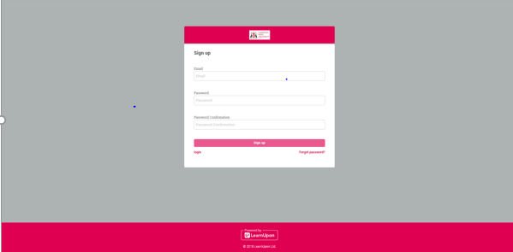

Step Five – On your screen, click ‘browse the catalogue’

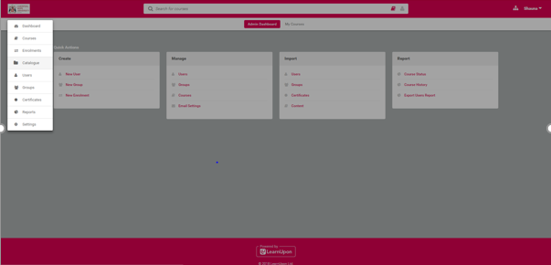

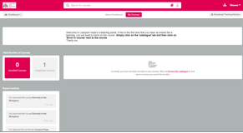

Step Six – There will be two options, please click on the chosen Module, Click ‘Enrol on Course’ and then ‘yes’ when the prompt comes up

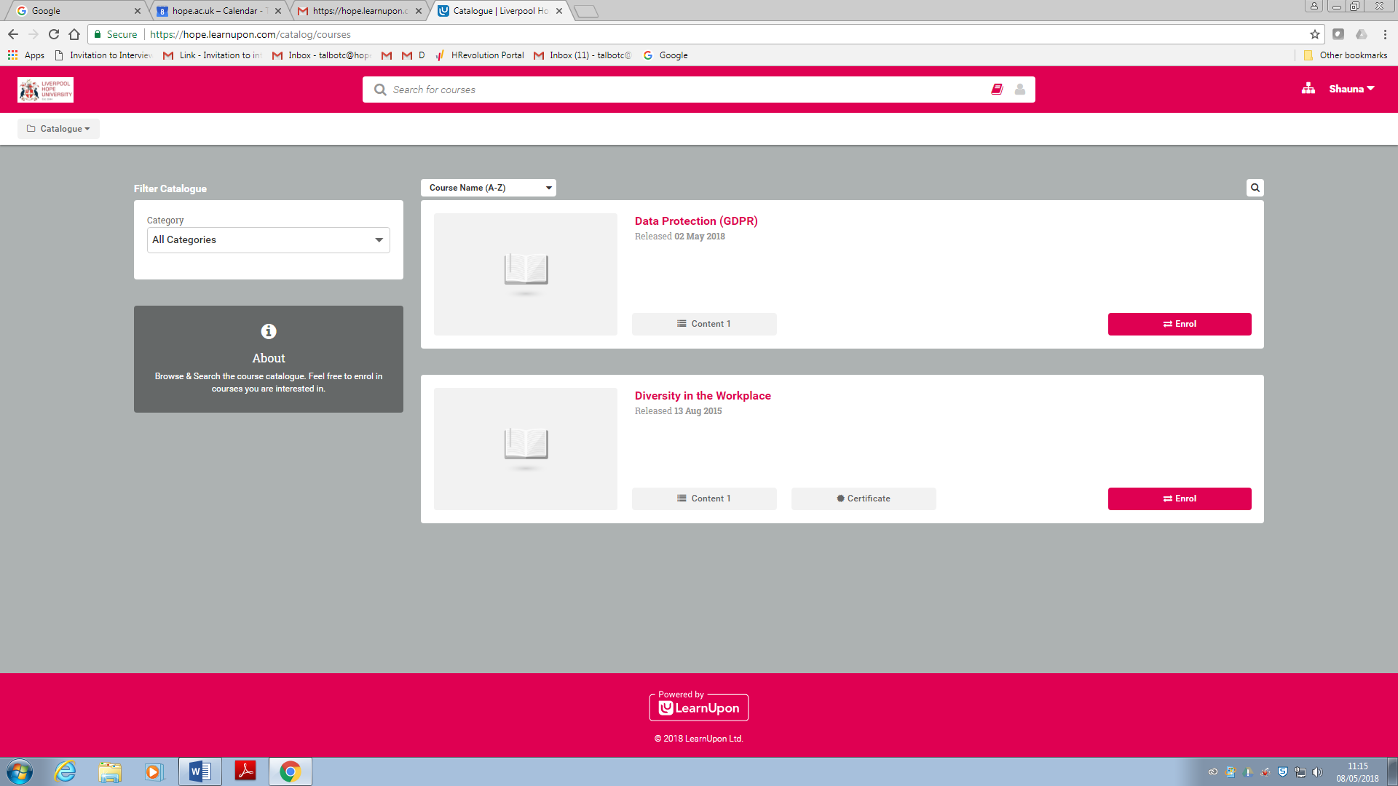

Step Seven – In order to commence the session, click ‘launch’ and follow the session through.
If you are using Google Chrome, the screen may appear black, this may be because of the google chrome settings. Please open a new webpage and copy the following link into your Chrome search bar: chrome://flags/#autoplay-policy
Scroll down to the highlighted area (should be in yellow)
Then change the policy to No user gesture is required, you should be able to continue with the course.

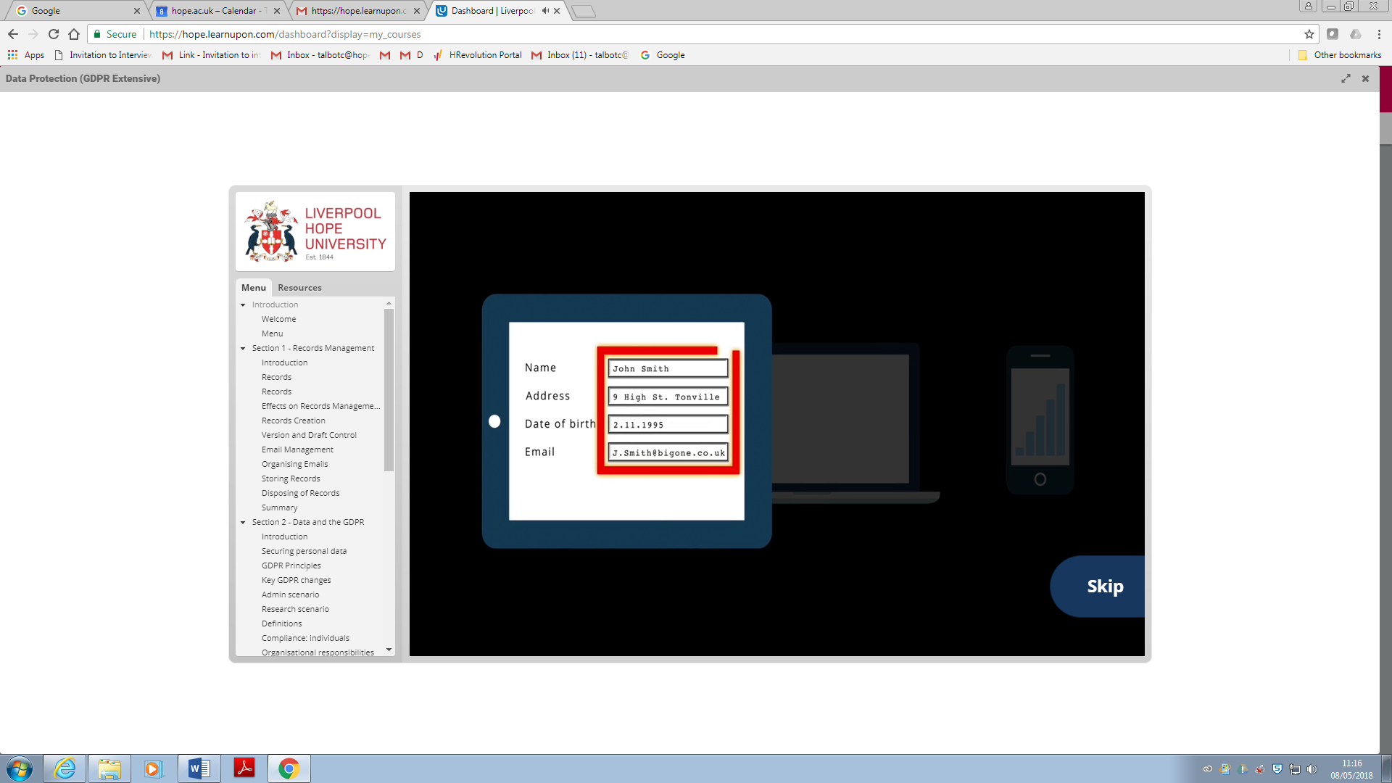
If you need to leave the session at any time:
